**BASAVARAJESWARI GROUP OF INSTITUTIONS**

**Ballari Institute of Technology & Management**

**AUTONOMOUS INSTITUTE UNDER VISVESVARAYA TECHNOLOGICAL UNIVERSITYJNANA SANGAMA, BELAGAVI 590018**

**INTERNSHIP**

**Report On**

# SPORTS BROADCASTING SCHEDULING TOOL

Submitted in partial fulfillment of the requirements for the award of degree of

**Bachelor of Engineering**

**In**

**ARTIFICIAL INTELLIGENCE AND MACHINE LEARNING**

## Submitted by

**D.VINDHU**

**3BR22AI037**

## Internship Carried Out By

**EZ TRAININGS & TECHNOLOGIES PVT.LTD HYDERABAD**

**Internal Guide External Guide**

**REDDY SANTHOSH KUMAR BEJIN SINGHA**

**Asst.prof,AIML Technical Trainer**

**MOHAMMED TOUSIF**

**Asst. prof,AIML**

### BALLARI INSTITUTE OF TECHNOLOGY & MANAGEMENT

NACC Accredited Institution*

**(Recognized by Govt. of Karnataka, approved by AICTE, New Delhi & Affiliated to Visvesvaraya Technological University, Belagavi)**

**"Jnana Gangotri" Campus, No.873/2, Ballari-Hospet Road, Allipur, Ballar1-583 104 (Karnataka) (India) Ph: 08392 – 237100 / 237190, Fax: 08392 – 237197**

**2023-2024**

**BASAVARAJESWARI GROUP OF INSTITUTIONS**

## BALLARI INSTITUTE OF TECHNOLOGY & MANAGEMENT

**Autonomous institute under VISVESVARAYA TECHNOLOGICAL UNIVERSITYJNANA SANGAMA,**

**BELAGAVI 590018**

NACC Accredited Institution*

**(Recognized by Govt. of Karnataka, approved by AICTE, New Delhi & Affiliated to**

**Visvesvaraya Technological University, Belagavi)**

### "JnanaGangotri"Campus,No.873/2,Ballari-HospetRoad,Allipur,

**Ballar1-583 104 (Karnataka)(India)**

**Ph: 08392 – 237100 / 237190, Fax: 08392 –237197**

**DEPARTMENT OF ARTIFICIAL INTELLIGENCE AND MACHINE LEARNING**

# CERTIFICATE

This is to certify that the Internship entitled **“ SPORTS BROADCASTING SCHEDULING TOOL ”** has been successfully completed by **D.VINDHU** bearing USN **3BR22AI037** a bonafide student of Ballari Institute of Technology and Management,

Ballari. For the partial fulfillment of the requirementsfor the **Bachelor’s Degree in Artificial Intelligence And Machine Learning** of the VISVESVARAYA TECHNOLOGICAL UNIVERSITY,

Belagavi during the academic year 2023-2024.

**Signature of Internship Signature of HOD**

**Co-ordinator**

**REDDY SANTOSH KUMAR DR.B.M.VIDYAVATHI**

**Asst.prof,AIML Prof. and HOD(AIML)**

**MOHAMMED TOUSIF**

**Asst. prof,AIML**

**DECLARATION**

I, **D.VINDHU,** second year student of Computer

Science and Engineering, Ballari Institute of Technology, Ballari, declare that Internship entitled **SPORTS BROADCASTING SCHEDULING TOOL** is a part of Internship Training successfully carried out by **EZ TECHNOLOGIES & TRAININGS PVT.LTD ,Hyderabad** at “**BITM,BALLARI”.** This report is submitted in partial fulfillment of the requirements for the award of the degree, Bachelor of Engineering in Computer Science and Engineering of the Visvesvaraya Technological University, Belagavi.

**Date : 04-05-2024 Signature of the Student**

**Place :BALLARI**

**ACKNOWLEDGEMENT**

The satisfactions that a company the successful completion of my internship on “ SPORTS BROADCASTING SCHEDULING TOOL ” would be incomplete without the mention of people who made it possible, whose noble gesture, affection, guidance, encouragement and support crowned my efforts with success. It is my privilege to express my gratitude and respect to all those who inspired me in the completion of my internship.

I am grateful to our respective coordinator **“Reddy Santosh Kumar(Asst.prof,AIML) , Mohammed Tousif (Asst.prof,AIML)”** for his noble gesture, support co-ordination and valuable suggestions given to me in the completion of Internship.

I also thank **DR.B.M.Vidyavathi,** H.O.D. Department of **Artificial Intelligence and Machine Learning** for extending all his valuable support and encouragement.

**Table of Contents**

|  |  |  |
| --- | --- | --- |
| **Chapter No.** | **Chapter Name** | **Page No.** |
| **1** | **Company Profile** | **06** |
| **2** | **Day to day activity(student diary extract)** | **07** |
| **3** | **Abstract** | **08** |
| **4** | **Introduction of the project** | **09** |
| **5** | **Description** | **10-11** |
| **6** | **Algorithm** | **12** |
| **7** | **Output** | **13** |
| **8** | **Conclusion** | **14** |
| **9** | **References** | **15** |

**CHAPTER 1**

COMPANY PROFILE

Company Name : EZ trainings and Technologies Pvt.Ltd

**Introduction:**

EZ Trainings and Technologies Pvt. Ltd. is a dynamic and innovative organization dedicated to providing comprehensive training solutions and expert development services. Established with a vision to bridge the gap between academic learning and industry requirements, we specialize in college trainings for students, focusing on preparing them for successful placements. Additionally, we excel in undertaking development projects, leveraging cutting-edge technologies to bring ideas to life.

**Mission:**

Our mission is to empower the next generation of professionals by imparting relevant skills and knowledge through specialized training programs. We strive to be a catalyst in the career growth of students and contribute to the technological advancement of businesses through our development projects.

**Services:**

**College Trainings:**

• Tailored training programs designed to enhance the employability of students.

• Industry-aligned curriculum covering technical and soft skills.

• Placement assistance and career guidance.

**Development Projects:**

• End-to-end development services, from ideation to execution.

• Expertise in diverse technologies and frameworks.

• Custom solutions to meet specific business needs.

**Locations:** Hyderabad | Delhi NCR

At EZ Trainings and Technologies Pvt. Ltd., we believe in transforming potential into excellence

**CHAPTER 2**

**Internship Program on Python for BE-3rd Sem students**

**From 15th April to 4th May 2024 (During 3rd semester vacations).**

**Student Name: GOURI USN No: 3BR22AI047 Branch: AIML**

|  |  |  |  |
| --- | --- | --- | --- |
| **INDEX PAGE** | | | |
| **Day** | **Date** | **Content Covered** | **Signature of the** |
| **faculty in-charge** |
| **1** | **15.04.24** | **Introduction to python, conditional & control statements, programs on leap year, prime number, GCD, LCM** |  |
| **2** | **16.04.24** | **Find reverse of number, multiply and add all digits in number, palindrome, even & odd number, factorial, fibonacci** |  |
| **3** | **17.04.24** | **Functions, datatypes, MCQ’s** |  |
| **4** | **18.04.24** | **List, programs based on list** |  |
| **5** | **19.04.24** | **Strings & recursion and based programs** |  |
| **6** | **20.04.24** | **OOPS concept** |  |
| **7** | **22.04.24** | **Searching & sorting (linear & binary search, bubble, selection & insertion sort)** |  |
| **8** | **23.04.24** | **Merge & quick sort, stacks & queues** |  |
| **9** | **24.04.24** | **Linked list** |  |
| **10** | **25.04.24** | **Trees** |  |
| **11** | **26.04.24** | **Graph** |  |
| **12** | **27.04.24** | **Project preparation** |  |
| **13** | **28.04.24** | **Project preparation** |  |
| **14** | **29.04.24** | **Project preparation** |  |
| **15** | **30.04.24** | **Project preparation** |  |
| **16** | **02.05.24** | **Project preparation** |  |
| **17** | **03.05.24** | **Presentation day** |  |
| **18** | **04.05.24** | **Presentation day** |  |

**CHAPTER 3**

ABSTRACT

1. User-Friendly Interface: The tool offers a simple interface through which broadcasters can easily manage their broadcasting schedules.

2. Event Creation: Users can effortlessly create new events by providing details like time, date, location, team, and team leader.

3. Real-Time Updates: Changes made to event details are instantly reflected, allowing for timely adjustments.

4. Comprehensive Management: The tool enables users to create, update, and delete events seamlessly, all from a sidebar menu.

5. Detailed Event Viewing: Users can view detailed information about scheduled events, including time, location, team, and team leader.

6. Feedback Mechanism: A built-in feedback system allows users to share their thoughts or report issues directly within the tool.

7. Data Persistence: Event data is securely stored and retrieved using JSON files, ensuring continuity in event management across sessions.

**CHAPTER 4**

INTRODUCTION OF THE PROJECT

* Scheduling is vital in sports broadcasting for audience engagement, revenue generation, and operational efficiency.
* Managing schedules involves complexities like event timings, venue availability, team schedules, viewer demographics, and advertising commitments.
* Technology advancements have led to sophisticated tools that automate, optimize, and customize scheduling decisions.
* Effective scheduling captures audience attention, boosts viewership, and increases audience satisfaction.
* It also maximizes advertising revenues by strategically placing events and optimizing ad placements.
* Streamlining scheduling processes improves operational efficiency for broadcasters.
* Modern scheduling tools use AI, machine learning, and data analytics for insights and optimization.
* These tools encompass features like event management, real-time updates, analytics, advertising integration, and feedback mechanisms.
* They benefit broadcasters, advertisers, sports leagues, and audiences by enhancing coordination, revenues, and viewer experience.
* Sports broadcasting scheduling tools are essential assets shaping the future of sports media for captivating content delivery and maximizing stakeholder value.

**CHAPTER 5**

MODULE DESCRIPTION

1. **SportsBroadcastSchedulingTool Class**:
   * **Initialization**: Upon instantiation, the class loads event data from a JSON file and initializes an empty dictionary for storing event information.
   * **Event Management Functions**:
     + **create_event()**: Presents a sidebar interface for users to input event details (time, date, location, team, team leader) and saves the event data.
     + **update_event()**: Allows users to select a date, retrieve existing event details, update them as needed, and save the changes.
     + **delete_event()**: Enables users to select a date and delete the corresponding event data.
     + **show_event_details()**: Displays event details (time, location, team, team leader) for a selected date.
   * **Feedback Function**:
     + **feedback()**: Provides a text area for users to submit feedback or report issues, with a button to submit the feedback.
2. **Main Function (main())**:
   * Initializes the Streamlit application and creates an instance of the SportsBroadcastSchedulingTool class.
   * Presents a sidebar menu with options to create, update, delete, or view event details, as well as submit feedback.
   * Calls corresponding methods based on the user's selection to perform the desired actions.
3. **Data Management**:
   * **load_event_data()**: Loads event data from a JSON file when the class is instantiated.
   * **save_event_data()**: Saves event data to a JSON file after any modifications are made.
4. **User Interface**:
   * Utilizes Streamlit to create a user-friendly interface with a sidebar menu for easy navigation.
   * Provides input fields and buttons for users to interact with and perform various scheduling tasks.
5. **Feedback Handling**:
   * Allows users to submit feedback directly within the application, promoting user engagement and continuous improvement.
6. **Error Handling**:
   * Provides warnings or success messages to users based on the outcome of their actions (e.g., event creation, deletion, feedback submission).
7. **Scalability**:
   * Designed to accommodate potential future enhancements or additional features to meet evolving user needs or industry requirements.

**CHAPTER 6**

ALGORITHM:

**1.Import Libraries:** The code starts by importing necessary libraries, such as streamlit and json.

**2.Define the Class SportsBroadcastSchedulingTool:**

* This class contains methods for managing event data, such as loading, saving, adding, updating, and deleting events.
* It also has methods for displaying event details and handling feedback.

**3.Define the main Function:**

* This function is the entry point of the Streamlit application.
* It creates an instance of the SportsBroadcastSchedulingTool class and defines the layout of the web app.

**4.User Interface:**

* The user interface is built using Streamlit widgets such as st.title, st.date_input, st.image, st.columns, st.selectbox, st.subheader, st.text_input, st.button, and st.text_area.
* Users can select a date, add events, update events, delete events, show event details, and provide feedback.

**5.Menu Actions:**

* Based on the selected menu option, appropriate actions are taken:
* Add Event: Allows users +to add a new event for the selected date.
* Update Event: Enables users to update an existing event for the selected date.
* Delete Event: Lets users delete an event for the selected date.
* Show Event Details: Displays details of events scheduled for the selected date.
* Feedback: Allows users to submit feedback or report issues.

**6.Execution:**

The main function is executed if the script is run as the main program.

**CHAPTER 7**

OUTPUT

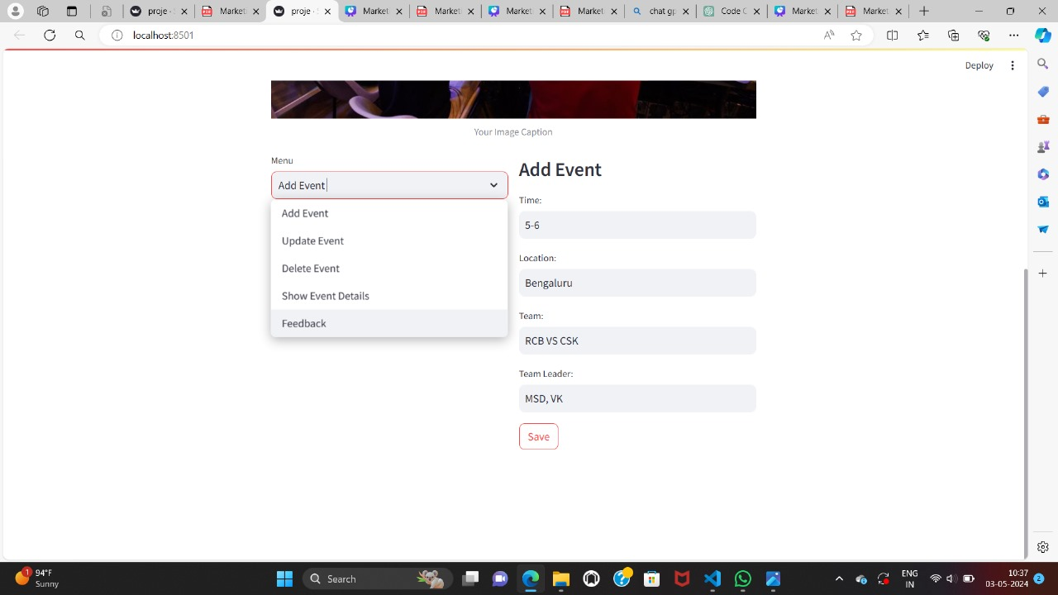

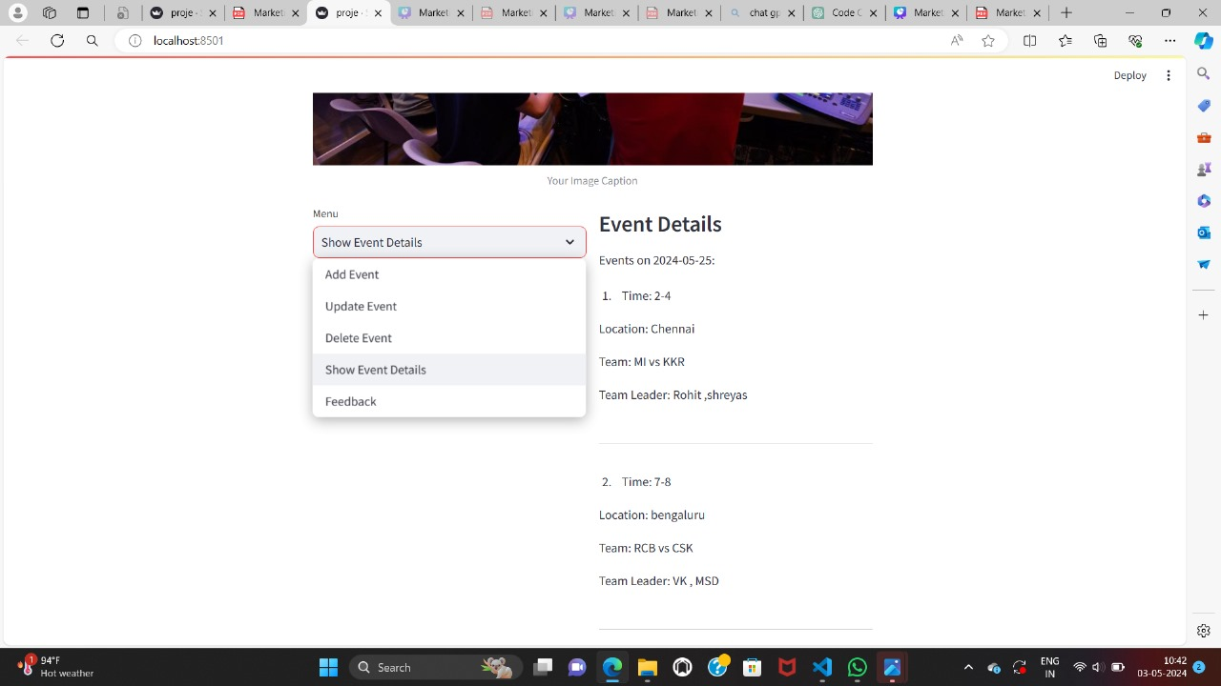

**CHAPTER 8**

CONCLUSION

The Sports Broadcasting Scheduling Tool provides a streamlined solution for managing sports event schedules. Its intuitive interface allows users to effortlessly add, update, and delete events, while also providing easy access to event details for specific dates. With reliable data management and effective error handling, it offers a user-friendly experience. Potential enhancements, such as implementing additional validation measures and refining feedback mechanisms, could further enhance its functionality. Overall, it's a valuable tool for efficiently organizing sports broadcasts.

**CHAPTER 9**

**REFERENCES:**

* https://chat.openai.com/c/fd7b734f-d486-4848-9fe2-1e3b8045facc
* google,class notebook
* streamlit